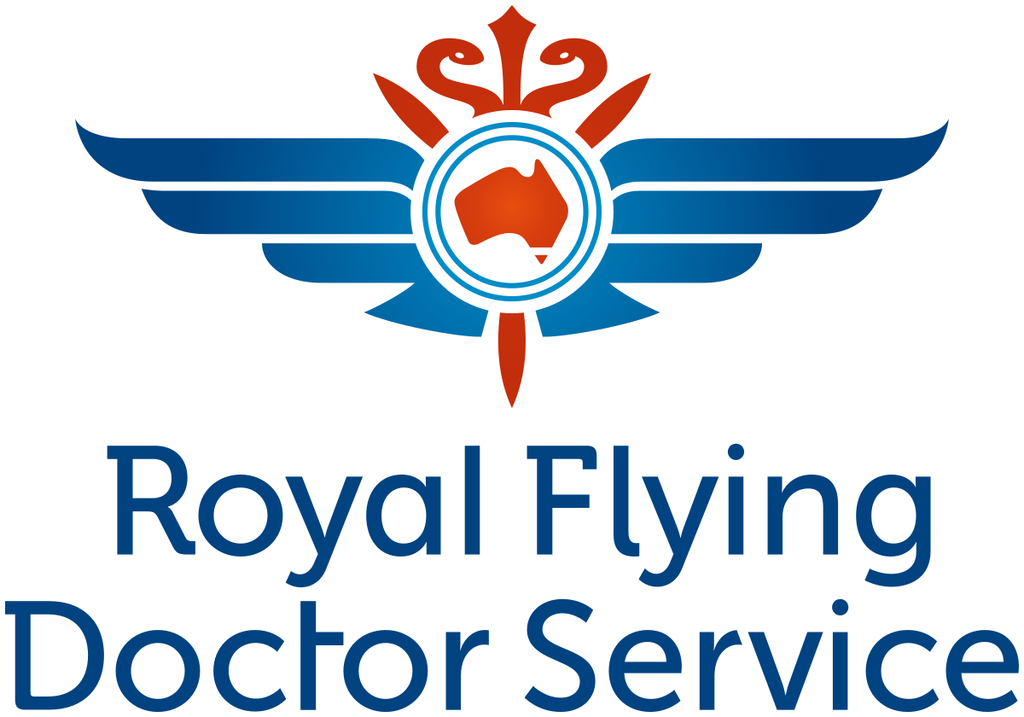
RFDS PITCH

*INTRO*
Hey how are you thanks so much for stopping!
Have you ever heard of the RFDS? You may have seen the TV show about us where the doctors and nurses fly into rural Australia and provide emergency care - that's us!

So we started in 1928 and for nearly 100 years we have been providing emergency medical care to Aussies all over the country.
To this day we are still doing daily emergency missions to make sure that people are kept safe. For example, these are the emergency missions we're currently flying right now!
*(Show map screen)*

*PROBLEM*
Even though we are such a big organisation, there is still limited access to medical care all over Australia and sometimes there are so many emergencies that we cannot get to those that need it the most.

Basically we just do not have enough planes and equiptment to meet the needs of our own people. For example one of these Jets can cost over 15Million

Sometimes people go weeks without urgent medical care, and we lose rural Australians at a much higher rate than those that live in the cities because of this.

Basically, people are unable to get psychiatric care, medical care, dental care and even things like suicide are nearly 2 times higher for rural Aussies.

Pretty sad right?

*SOLUTION*
That's why we're here don't worry. Pretty much we know that if we were to add more fleets of planes and more equipment that we could reach those Aussies that are dying unnecessarily.

So why we pulled isn't for 15,000,000 you're safe :). But basically if we could get as many Aussies as we can to chip in with sometimes small like $6-8-12 a week, we can purchase more planes and equiptment for these Aussies.

*CLOSE*
So basically we're asking people to register with us today and sacrifice something like that regularly for as long as they can.
Sound good? Sweet what's your first name?

